

JTI
Trade Marketing Excellence Programme

Deletion of Contact Entity on OLTP

DOCUMENT HISTORY
Title
Deletion of Contact Entity on OLTP

REVIEWS
NAME | DATE | SIGNATURE

APPROVALS
NAME | DATE | SIGNATURE

VERSION HISTORY
VERSION | EFFECTIVE  DATE | SUMMARY OF CHANGES | WRITTEN BY | STATUS
0.1 | 05/07/2010 | Initial Version | Veedhya Bholah | Closed
0.2 | 31/03/2015 | Revise Contact deletion impacted tables | Riteswaree Seewooruttun | Closed
0.3 | 06/05/2015 | Revise Contact deletion impacted tables | Riteswaree Seewooruttun | Open
0.4 | 01/12/2017 | Generic Script added for backups of impacted table & new trick for segment batch as per INC2137136 | Gulraaz Usmani  Misa Cyprienna | Open

DISTRIBUTION HISTORY
VERSION | COPY | ISSUED TO | DATE | ACTION REQUIRED

1. Introduction

This document gives the high-level description of the steps required for the deletions of Contact entity data in Siebel OLTP (on S_CONTACT table).

The main table for the contact entity is S_PARTY table as shown below. This is identified by the * from the EIM mapping extract for the EIM_CONTACT table (the interface table for contacts deletions).

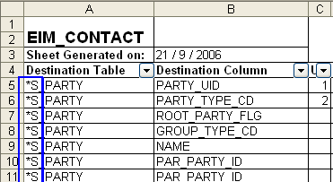

For contact deletion, we perform the deletion on the S_PARTY table directly and this will cascade delete the corresponding records in the S_CONTACT table.

2. Performing backups before deletion

  - List of all impacted tables

S_PARTY
S_ADDR_PER
S_CONTACT_BU
S_CONTACT_INFO
S_ACT_CONTACT
S_AGENT_DETAIL
S_ALGN_POS_CON
S_APPL_CON
S_ARREST
S_ARREST_CON
S_ASSET_CON
S_AUC_ALRT
S_AUC_ALRT_DEF
S_AUC_BID
S_AUC_RATING
S_AUC_WATCH
S_BNFT_PLAN_ITM
S_BP_CON_LS
S_CASE_LD_CON
S_CASE_PER
S_CERT_ATTR_PER
S_CIF_CON_MAP
S_CONTACT_ALIAS
S_CONTACT_ATT
S_CONTACT_FNXM
S_CONTACT_ISS
S_CONTACT_KEY
S_CONTACT_LSXM
S_CONTACT_REL
S_CONTACT_TNTX
S_CONTACT_TNXM
S_CONTACT_XM
S_CON_BRD_SPEC
S_CON_CHRCTR
S_CON_CLASS_RNK
S_CON_DMGRPHC
S_CON_EDU
S_CON_INDUST
S_CON_LOCTN
S_CON_PGROUP
S_CON_PHONE
S_CON_PRDEXT
S_CON_PRDINT_M
S_CON_PRFTBLTY
S_CON_SKILL
S_CON_TERR
S_CON_WELL_PROG
S_CON_XPERIENCE
S_CRDT_RPT_CON
S_CURRCLM_PER
S_DISEASE_PER
S_DRVR_LICENSE
S_DRVR_RECORD
S_ENTLMNT_CON
S_EVIDENCE_CON
S_EVT_STAFF
S_EVT_TRVL_PER
S_EXP_ITEM_CON
S_FN_AAGSVC_CON
S_FN_ASSET_LIAB
S_FN_ASTLB_CON
S_FN_INCEXP_CON
S_FN_INCM_EXP
S_FN_INSCOB_CON
S_FN_NEED
S_FN_NEED_CON
S_FN_PER_APPR
S_FN_RCMD_CON
S_FUNC_CON
S_GROUP_CONTACT
CX_AGR_PL_ITEM
CX_AGR_PTS_TXN
CX_PTS_TXN
CX_TERR
S_ACT_SIGN
S_ALERT_CUT
S_ASSESS
S_ASSESS_TNTX
S_ASSET
S_AUC_ITEM
S_CALL_LST_CON
S_CAMP_CON
S_CASE
S_CF_INSURANCE
S_CL_PTCL_LS
S_CL_ST_ADDR_LS
S_CM_MSG_STAT
S_COMMUNICATION
S_COMM_CON
S_COMM_LOG
S_CONTACT
S_CONTACT_LOYX
S_CON_ADDR
S_CON_MKT_SEG
S_CON_PAYEE
S_CRSE_TSTRUN
S_CS_RUN
S_CUST_SURVEY
S_DD_USER_KEY
S_DOC_AGREE
S_DOC_CORR
S_DOC_PPSL
S_DOC_QUOTE
S_ESCL_ACTION
S_EVTLOC
S_EVT_ACT_LSX
S_EVT_ACT_X
S_EVT_FUL_REQ
S_EVT_VENUE_RVW
S_EVT_VNDR_RVW
S_EXP_RPT
S_FCST_ITEM
S_FINAN_PROF
S_FNCVRG_ELMNTS
S_FN_ACCNT1_FNX
S_FN_BILL
S_FN_CVRG_ROLE
S_FN_HLTH_ENCTR
S_FN_OFFR_COLT
S_FN_RCMD
S_FN_STMT_ADDR
S_FUL_RECIP
S_HLTH_CARE_SR
S_HLTH_RISK
S_INCIDENT
S_PARTY_PER

2.2 Script to backup the invoice table and child tables impacted:

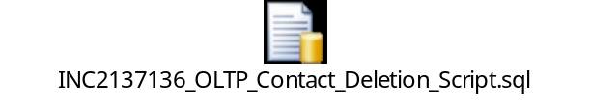
3. Populating EIM table for deletion

The user keys required for S_PARTY deletion are PARTY_UID, PARTY_TYPE_CD and ROOT_PARTY_FLG as shown below:

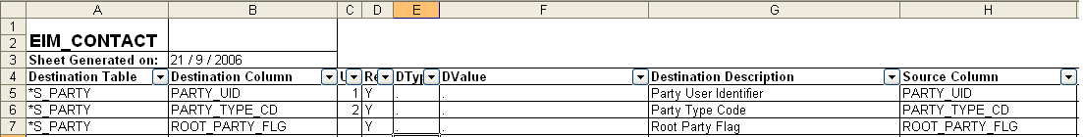

The following script is used to insert data into the EIM table for deletion:

- Perform cleansing of EIM batch

DELETE FROM EIM_CONTACT
WHERE IF_ROW_BATCH_NUM BETWEEN 800000 AND 800999

- Populate EIM table with reference of records to be deleted

INSERT INTO EIM_CONTACT (ROW_ID, IF_ROW_BATCH_NUM, IF_ROW_STAT, CON_PERSON_UID, CON_BU, PARTY_UID, PARTY_TYPE_CD)
SELECT S_CONTACT.ROW_ID, 800000+ ROW_NUMBER() OVER (ORDER BY S_CONTACT.ROW_ID)/1000, 'FOR_DELETE', S_CONTACT.PERSON_UID, S_BU.NAME, S_PARTY.PARTY_UID, S_PARTY.PARTY_TYPE_CD
FROM S_CONTACT (NOLOCK)
INNER JOIN S_PARTY (NOLOCK)ON S_CONTACT.PAR_ROW_ID=S_PARTY.ROW_ID
INNER JOIN S_BU (NOLOCK) ON S_BU.ROW_ID=S_CONTACT.BU_ID
WHERE S_CONTACT.ROW_ID IN (SELECT ROW_ID FROM StagingDB.dbo.CN_TO_BE_DELETED)

- Check EIM table:

SELECT IF_ROW_BATCH_NUM, IF_ROW_STAT, COUNT(1)
FROM EIM_CONTACT(NOLOCK)
WHERE IF_ROW_BATCH_NUM BETWEEN 800000 AND 800999
GROUP BY IF_ROW_BATCH_NUM, IF_ROW_STAT
ORDER BY 1
4. Launching the deletion

The following ifb needs to be launched on the Sales Application to perform deletion. Before launching the ifb perform the following:
- Check correct transaction logging in ifb
- Batch range in ifb
- Place the ifb on the ADMIN folder for the corresponding environment

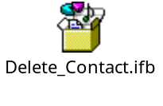

Follow the steps below to launch the ifb:

1. Log into the Sales Application on the corresponding environment
2. Click on the site map icon
3. Click on Administration - Server Management
4. Click on jobs under Administration - Server Management
5. Launch the ifb with the parameters shown below:

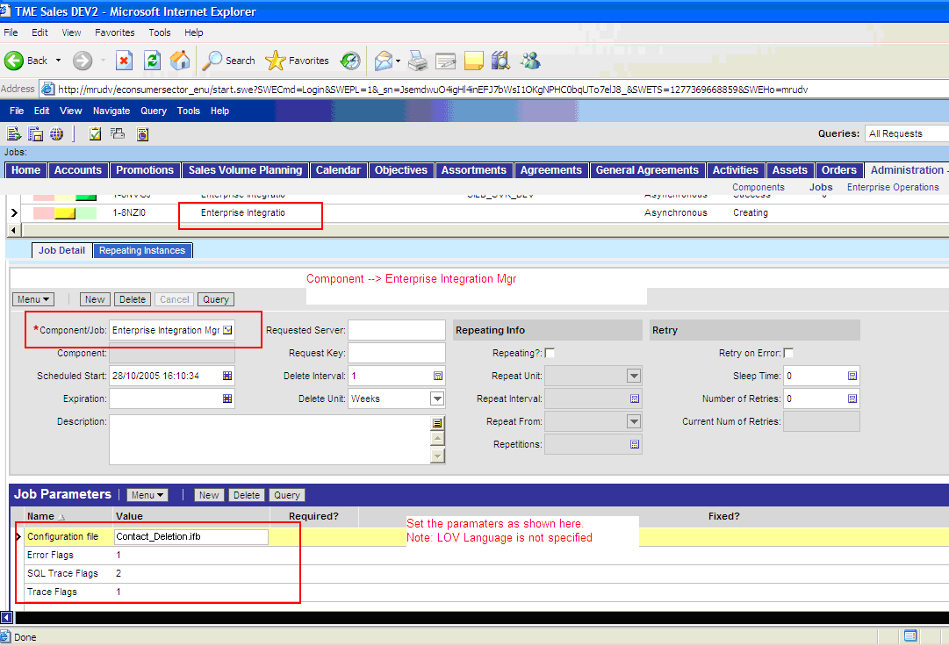
5. Monitoring the deletion operation & final check

Use the following query to monitor the status on the deletion:

SELECT IF_ROW_BATCH_NUM, IF_ROW_STAT, COUNT(1)
FROM EIM_CONTACT(NOLOCK)
WHERE IF_ROW_BATCH_NUM BETWEEN 800000 AND 800999
AND IF_ROW_STAT = 'FOR_DELETE'
GROUP BY IF_ROW_BATCH_NUM, IF_ROW_STAT
ORDER BY 1

The Status of IF_ROW_STAT should be ‘DELETED’. If any other status is obtained, then investigation is required (See next section).

Debugging the Delete Operation & Typical issues Encountered

If the status of the deletion on the EIM table is not correct, then go to the corresponding EIM process log folder and search for the EIM process log. Go through the log and search for errors reported. If the error log does not give any idea about the issue, then increase the log level of the EIM process to 1,8,9 instead of 1,2,1.

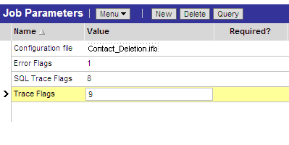

The common problematic IF_ROW_STAT obtained are:

- NO_SUCH_RECORD

This status is obtained when the process is not able to find the user keys provided in the EIM table. Check the user keys populated to ensure they are the correct ones.

- AMBIGUOUS

This status is obtained when the process finds the user keys provided more than once. In this case, the process gets confused to delete which record. Check for duplicate user keys and try to eliminate them.

6. Checking delete operation in database

Use the following query to check if the deletion has been correctly done on DB level:

SELECT *
FROM S_CONTACT
WHERE ROW_ID IN (SELECT ROW_ID FROM StagingDB.dbo.CN_TO_BE_DELETED)

If the deletion has been successfully completed, no record should be returned by the above query.

7. Checking delete in Siebel Application

Take a few sample accounts from the backup table using the query below and query them on the Sales Application on Contacts screen.
No records should be returned by the Sales Application query.

SELECT *
FROM S_CONTACT
WHERE ROW_ID IN (SELECT ROW_ID FROM StagingDB.dbo.CN_TO_BE_DELETED)

